**Mohammed Al Madhi**

**CIS 480**

**FALL 2020**

**Lab 3 - Packet Tracer**

|  |
| --- |
| * This is an assignment, and worth 2 points. * The due date is the next day midnight. It will be graded as pass/fail (2 or 0 points). * Submit the outcome & three *.pkt file. |

**Task 1**. Complete all the Parts in the following file: *2.1.1.2 Packet Tracer - Deploying Devices.pdf*. Build on the attached file: *2.1.1.2-Deploying Devices.pkt*.

- Take a screenshot of the outcome (refer to p. 3).

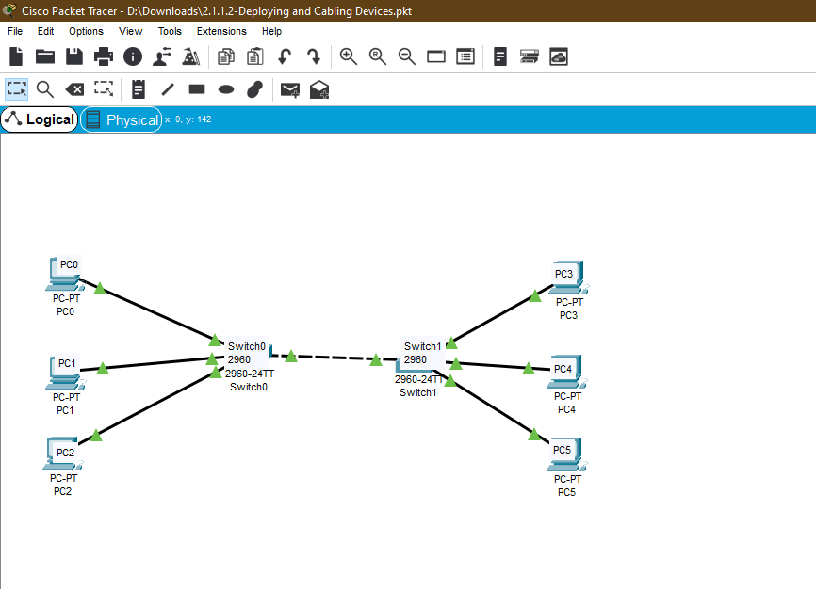

**Task 2.** Complete all the Parts in the following file: *2.1.1.2 Packet Tracer - Deploying and Cabling Devices.pdf*. Build on the attached file: *2.1.1.2-Deploying and Cabling Devices.pkt*.

- Take a screenshot of the outcome (refer to p. 4).

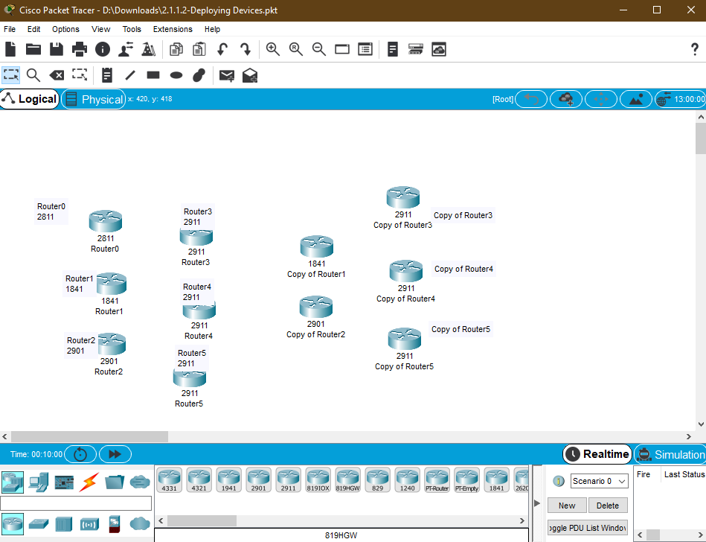

**Task 3**. Complete all the Parts in the following file: *2.1.1.4 Packet Tracer - Configure End Devices.pdf*.

- Take a screenshot of the outcome of ping (refer to p. 3).

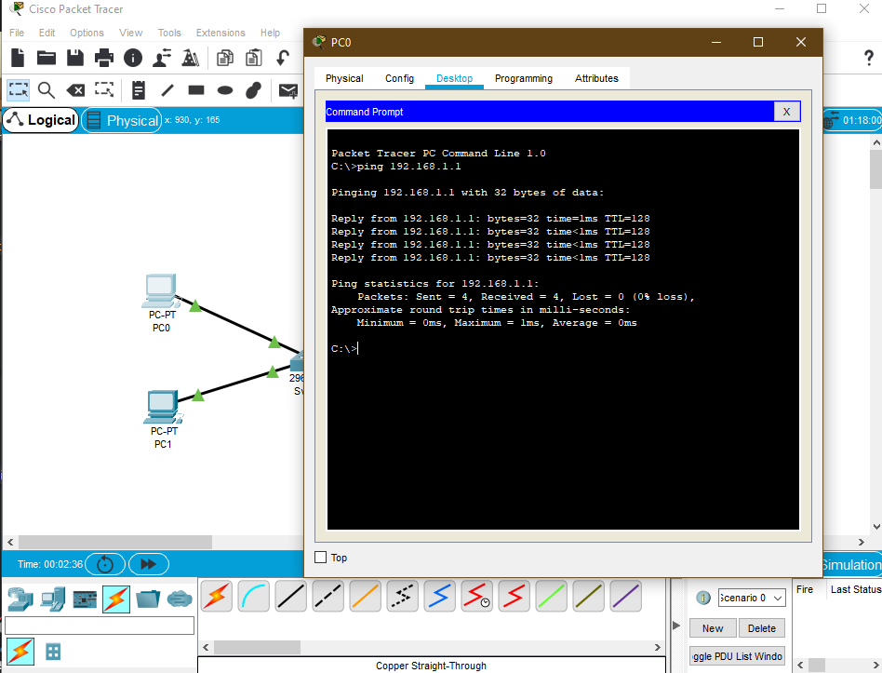

- Take a screenshot of the outcome of running IOS commands (refer to p. 7).

